Purpose Of This Work Instruction.

This Work Instruction describes those actions to be taken to restore a single file back to a VM guest using a manual Snap Clone process. It includes processes for both Solaris and Windows based VM guests

Prerequisites.

- The following prerequisites must be met prior to executing this work instruction:
- A good understanding Of NetApp technologies (especially Flexclone)

- A good Understanding of VMware and VCenter technologies

- Root access to the NetApp Filer.

- Full administrative rights to VCenter


Note

If a you are not completely confident with this process Do Not Continue without seeking
Further advice!

Contact Details.
DCMSStorage@thomsonreuters.com & DCMSStorage@thomsonreuters.com

Instructions.

Information Gathering
All information should be gathered prior to the comencement of any of the below restore processes.

The following information if required

- VM Cluster/VC Server
- NetApp Filers providing datastore
- NetApp Vfiler providing datastore
- Datastore name.
- Full path to required data.
- ESX servers to be used for restore process.
- Date and time of required restore.
- OS of VM Guest

Manual Process for NetApp FlexClone Creation
  - Logon onto the Netapp Filer with root privileges.

  - Check that the NetApp Filer has a valid FlexClone license installed

Filername>license

  - Check current snapshots available

Filername>snap list <volume_name>

Determine snapshot required to create your clone from and make a note of it.

  - Create a clone from your selected snapshot

Filername>vol clone create <volume_name>_clone -s none -b <volume_name> <snapshot_name>
Example: vol clone create vol1_clone –s none –b vol1 nightly.11

  - Check the status of the clone you have just created

Filername>vol status <volume_name>_clone

  - Identify the qtree that you will be exporting

Filername>qtree status -v <volume_name>_clone

  - Add the volume to the correct vfiler

Make a note of the vfiler name

Filername>vfiler add <vfiler_name> /vol/<volume_name>_clone

  - Export the required qtree to the ESX server/servers as identified by the platform group to be used for the recovery

You will need:

VFiler name
ESX Server IP
Path to qtree: /vol/volume_name_clone/qtree_name

    - Export the qtree as follows:

Filername>vfiler run <vfiler_name> exportfs -p rw,root=<esx_server_ip or esx_server_name> /vol/<volume_name>_clone<qtree_name>

Manual Process for Connecting Cloned Drive to VM

  - You should now add this datastore on the selected ESX Server. At this point you can present the VMDK you need to the VM and recover the file as shown in figure 1.

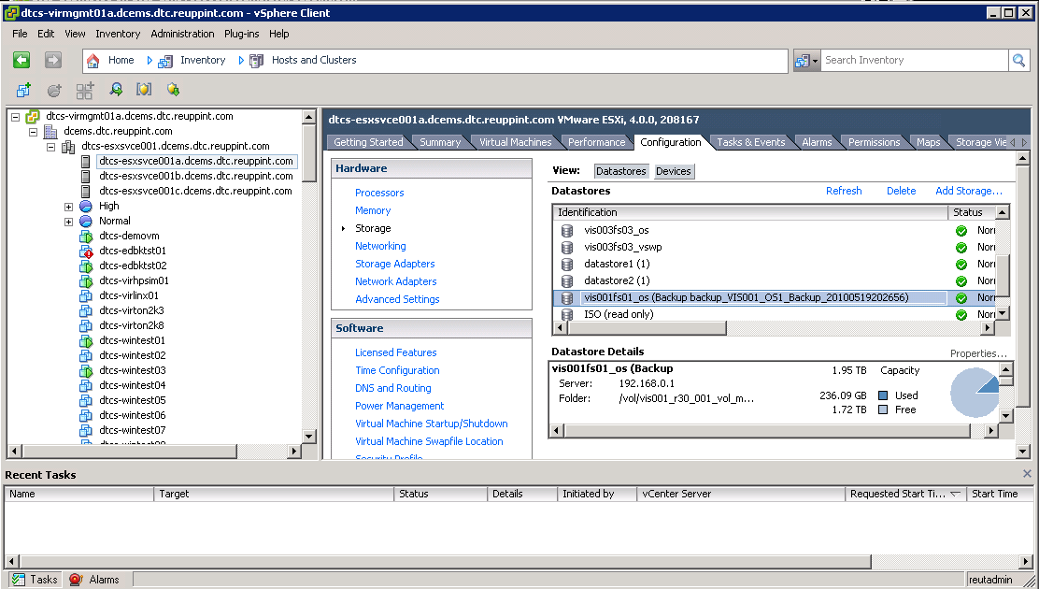
Figure 1 – Showing the mounted backup as an extra NFS data store
  - Connect the virtual disk within the mounted backup to the VM by editing the VM settings and browsing to the copy of its virtual disk, as shown in figure 2

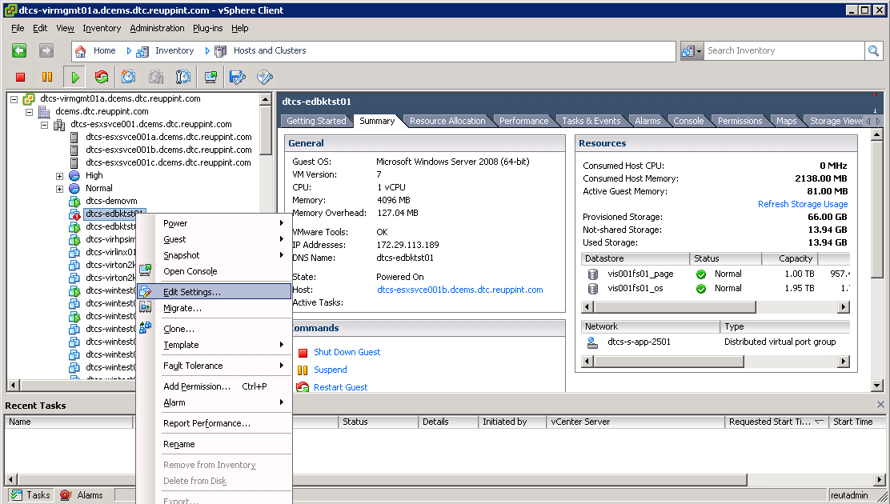
Figure 2 – Editing the VM settings to add a disk from the mounted backup
  - Click the “add” button to allow addition of a new hardware device as shown in figure 3

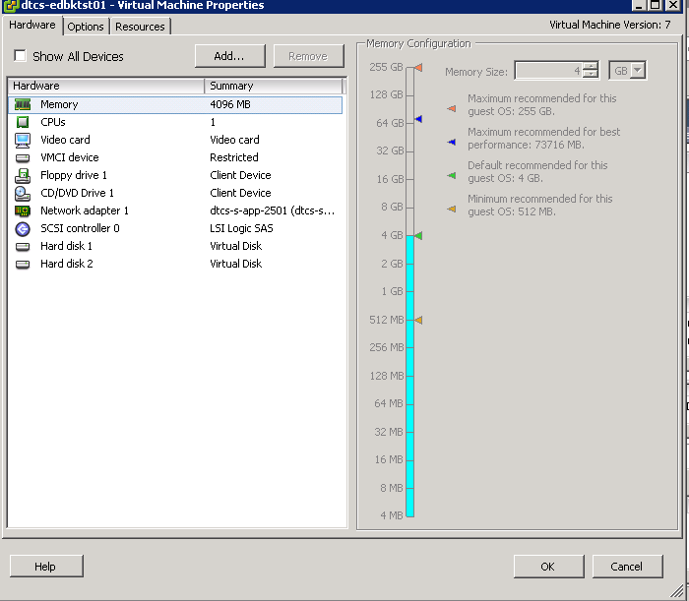
Figure 3 - Selecting hardware to add to a VM
  - Select device type as “hard disk”. Figure 4

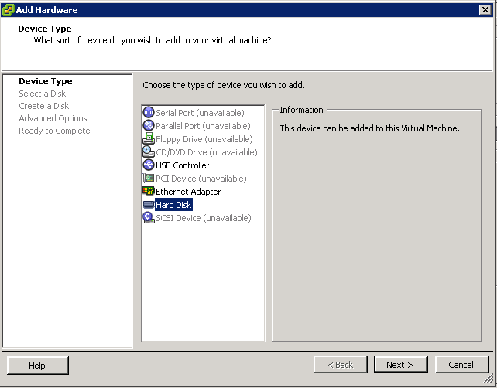
Figure 4 - Selecting Hard disk as hardware to add to a VM

  - When asked, select “Use an existing virtual disk” radio button. Figure 5
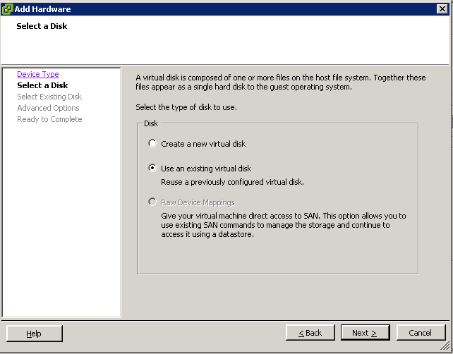
Figure 5 - Selecting to use an existing virtual disk

  - Click “Next”, then browse to the mounted backup data store. Figure 6

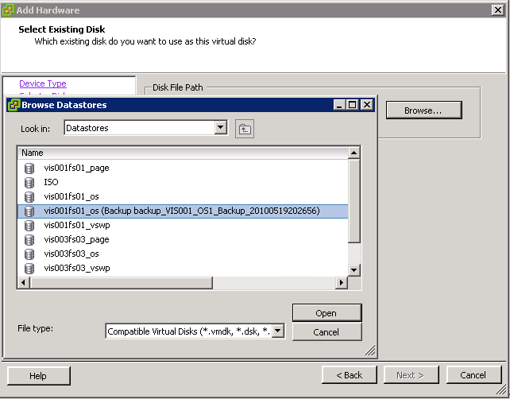
Figure 6 - Selecting the data store that contains the virtual disk

  - Select the folder holding the VM data and configuration files and click “open”. Figure 7
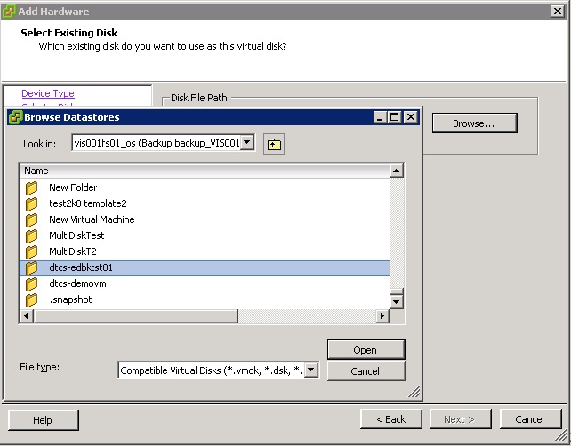
Figure 7 - Finding the folder that holds the VM data and configuration files

  - Select the .vmdk file that contains the virtual disk that holds the file requiring recovery. Click “OK”. Figure 8
Note

if a VM contains multiple disks, you will need to check beforehand which virtual disk contains
the files that need restoring.

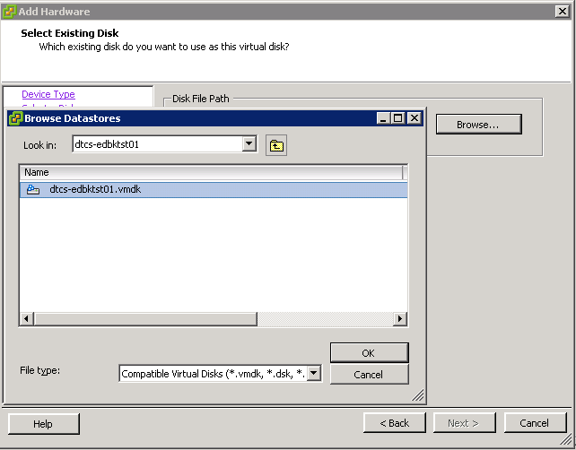
Figure 8 - Selecting the .vmdk that holds the file(s) to be restored

  - Confirm this is the disk you wish to connect to the VM by clicking “Next”. Figure 9
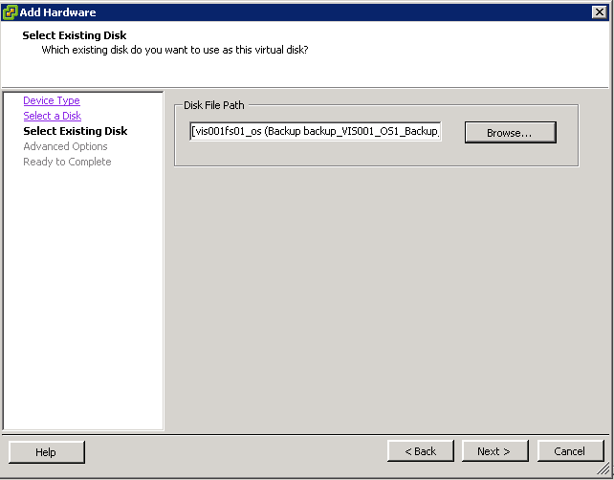
Figure 9 - Confirming selection of virtual disk

  - Take the default settings on the next page of the wizard. Click “Next”
  - Click “finish” to allow the disk to be connected to the VM, the system will say it is adding the virtual disk. Figure 10
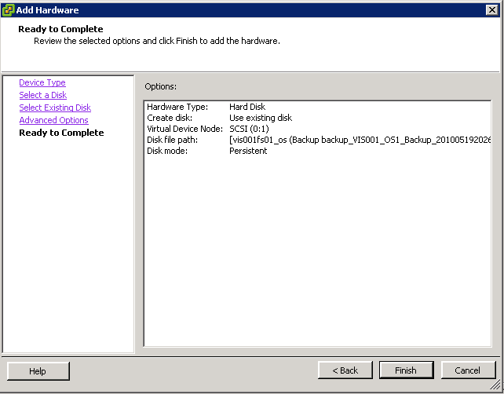
Figure 10 - Summary page of the Add Hardware wizard
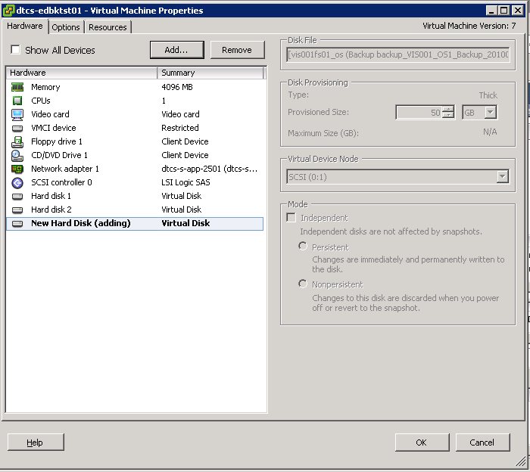
Figure 11 - Confirming adding a new virtual disk to a VM

  - Click the “OK” button and the vCenter task pane should show the VM being reconfigured with the new virtual disk Figure 12

Figure 12 - vCenter showing disk being added to VM

  - When the disk is being added vCenter will show that the virtual disk has the same UUID as the existing disk, this can be ignored. Select the “yes” radio button and click OK. Figure 13

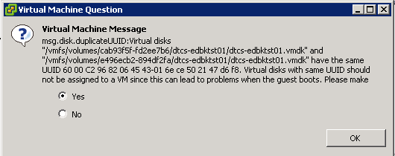
Figure 13 - Confirming that the same UUID is OK to add to the VM

  - The vCenter task pane will confirm you have agreed to add a disk with the same UUID Figure 14
Figure 14 - vCenter confirmation that the same UUID has been agreed

Note

If a VM is a Windows Guest Now follow Section 3!
If the VM Guest is Solaris follow Section 4

Restoring a single file on a VM running WINDOWS
  - On the VM console find the copy of the virtual disk in the operating system. The disk should appear as a new drive letter, but with the same label (System (F:) in this case) Figure 15

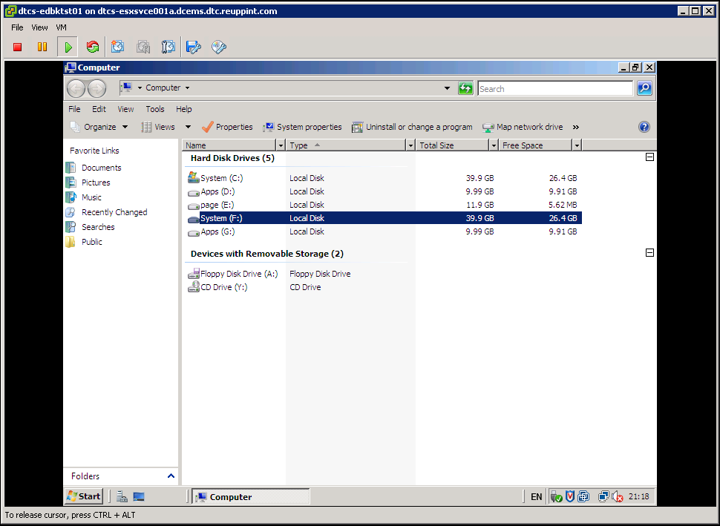
Figure 15 - Showing the newly attached disk in the VM console
  - Find the file to be recovered in the newly attached disk.

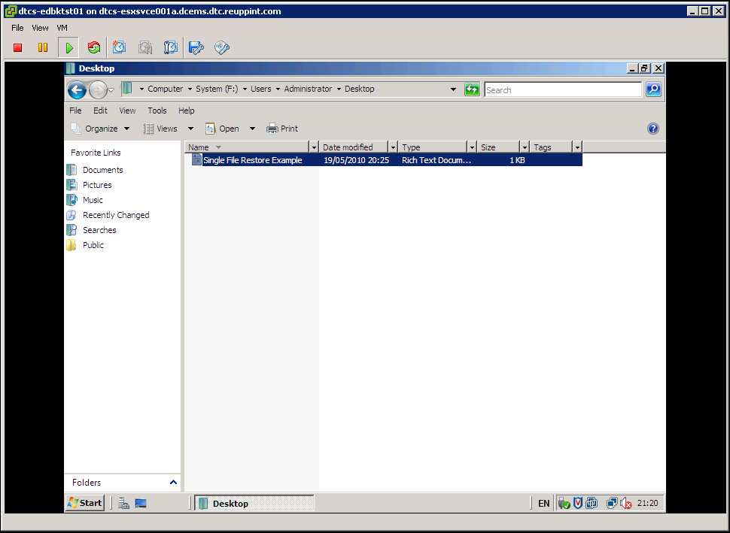
Figure 16 - Finding the file to be restored in the newly attached disk
  - Copy the file back to its original location, or if the file it already there and this is a second copy then copy into another location such as a restore folder.

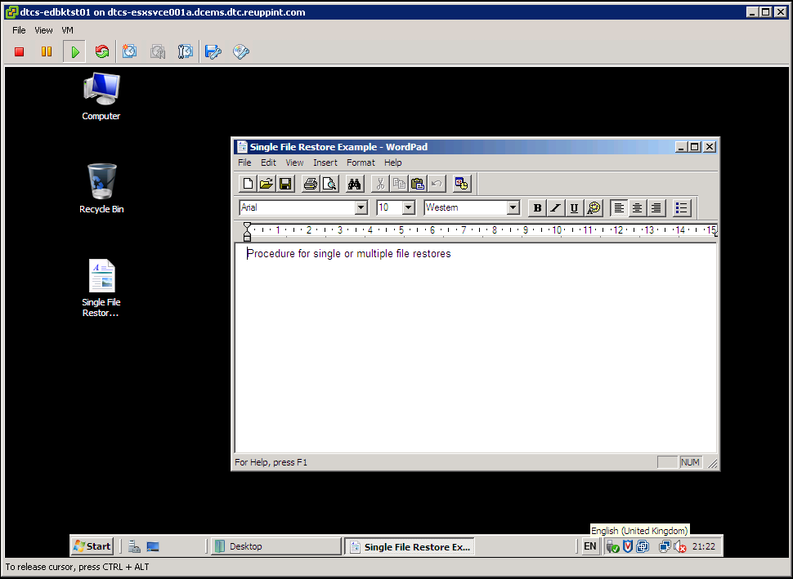
Figure 17 - Copying the file back to the VM

  - File restoration is now complete, disconnect the virtual disk.
  - Before remove disks/mounts check with customer for restore success.
  - Proceed to section 6 RESTORE MOUNT REMOVAL

Restoring a single file on a VM running Solaris
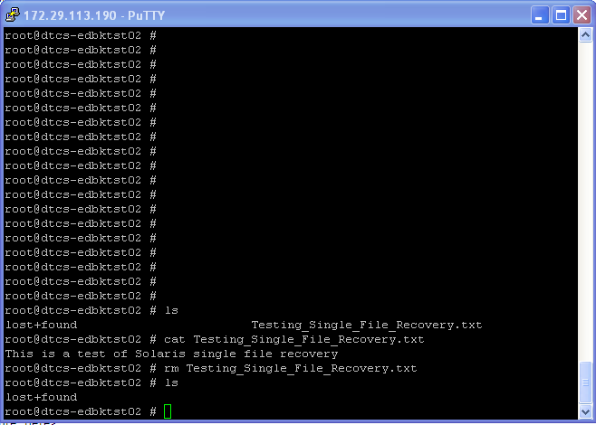
Figure 1 – Removal of file

  - Now mount the backup containing the copy of the file and mount as per the procedure previously described.

  - When the disk is connected run the “devfsadm” command to expose the disk to the VM. Confirm the disk can be seen by running “echo | format” command to show the extra disk in the VM

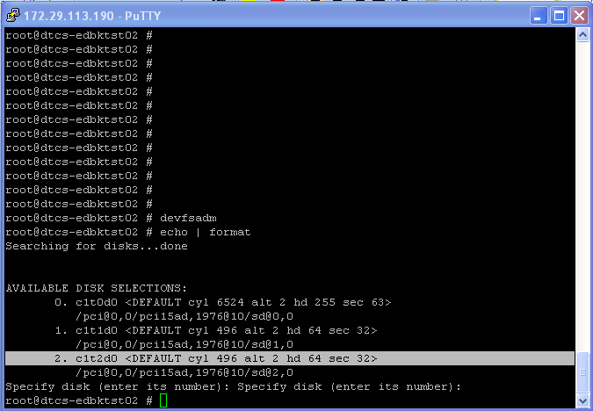
Figure 2 – Showing the disk connected to the VM
  - Once the disk is seen the restore procedure is dependent on the version of the Solaris build. If the Solaris build is using UFS file system then use the procedure below.

  - Mount the partition that contains the data to be restored to an available mount point, and copy the file back to its original location, or into a recovery area.
Mount the partition “mount /dev/dsk/cxtxdxsx /mnt”
  - Change directory to the mount that holds the restore file “cd /mnt/x/x”
  - Copy the restore file(s) to a restore folder “cp [-r] <filename> <destination>”

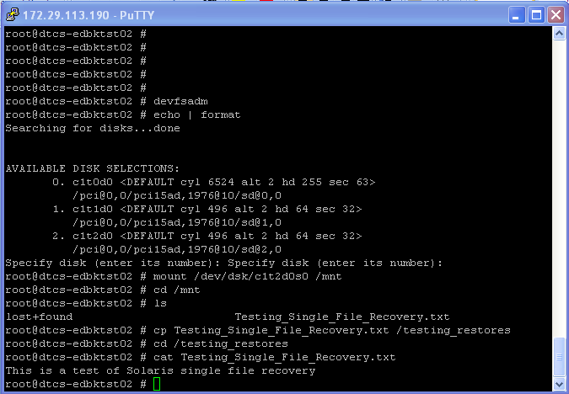
Figure 3 – Copying the recovered file back to its original location

  - Now unmount the filesystem and disconnect the disk from the VM.
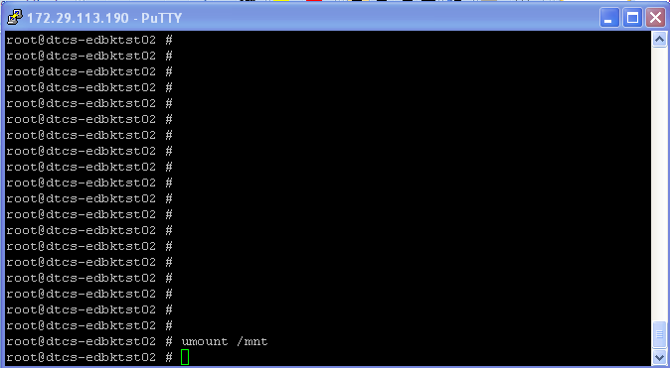
Figure 4 - unmounting the filesystem from the VM
  - Remove the disk from the VM by running the cfgadm command. The restore is now complete.
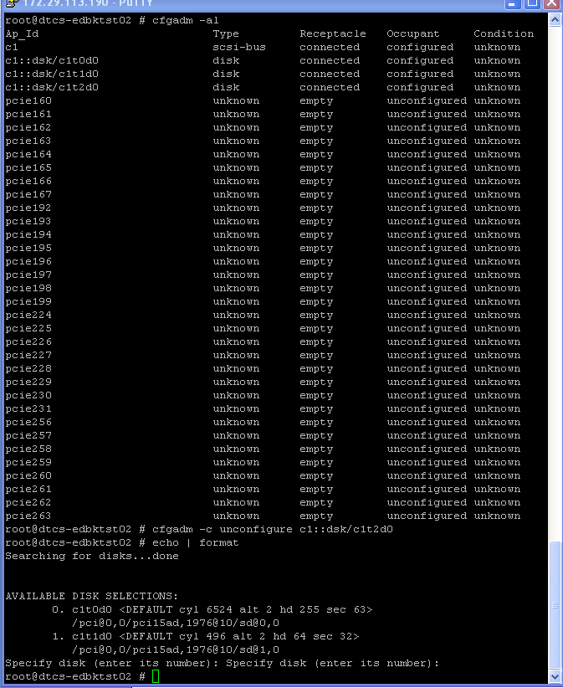
Figure 5 – Removing the disk from the VM

RESTORE MOUNT REMOVAL
  - Select the VM within vCenter and edit its settings
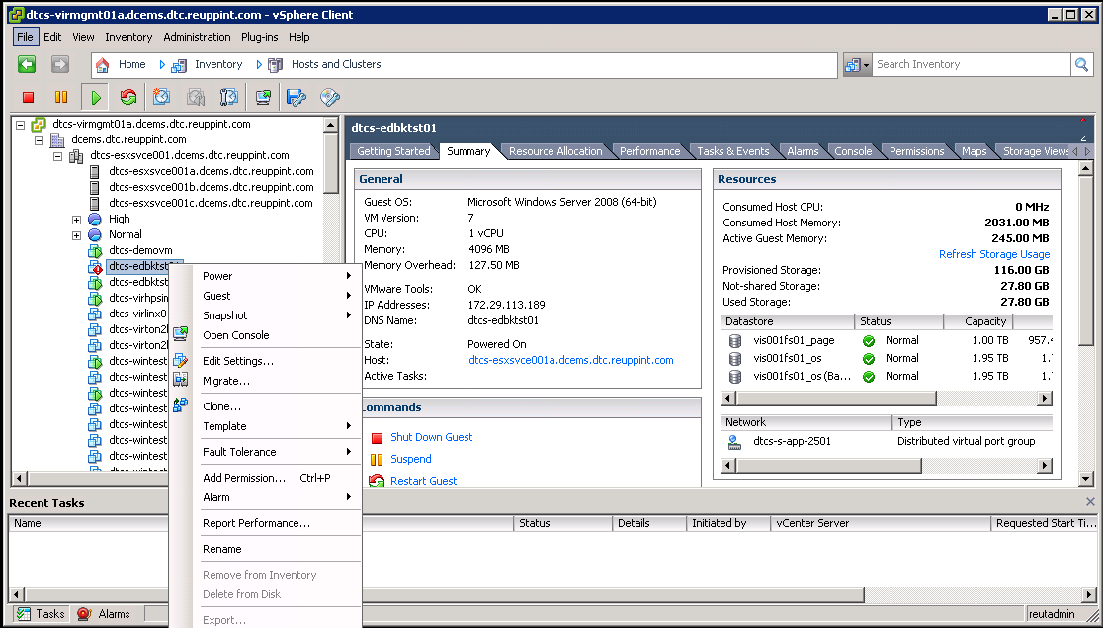
Figure 18 - Editing the VM settings to remove the virtual disk

  - Select the disk previously added and select remove. Confirm this is the correct disk by looking at the data store that this disk is located in – ensure it is the one that was mounted previously from the backup.
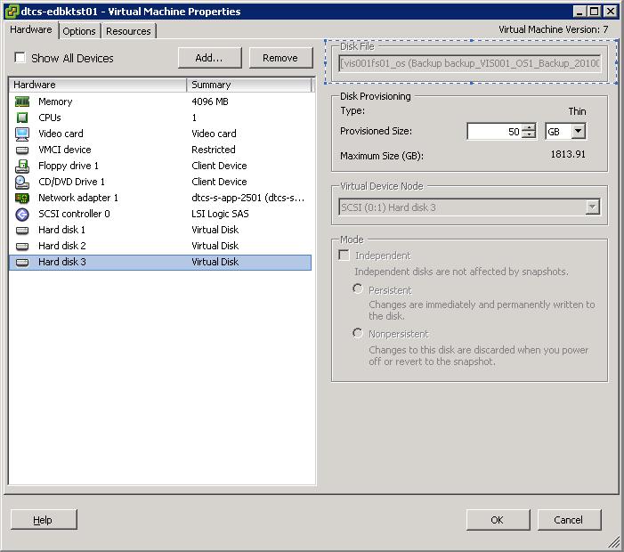
Figure 19 - Disconnecting the disk holding the file to be restored

  - Ensure Remove from virtual machine radio button is selected.
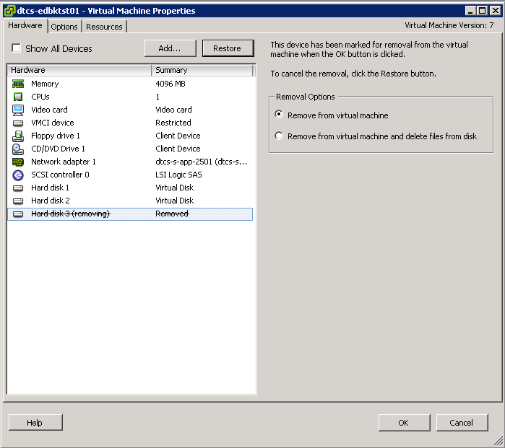
Figure 20 - Removing disk from VM

  - Click OK to confirm the removal - the vCenter task pane should show this taking place.
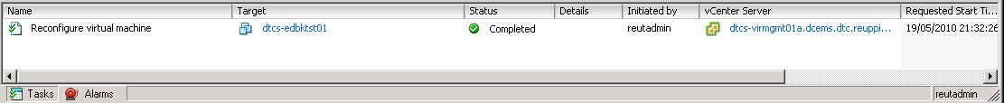
Figure 21 - vCenter task pane showing removal of a disk from the VM

  - The disk VM will not now be able to access the disk.
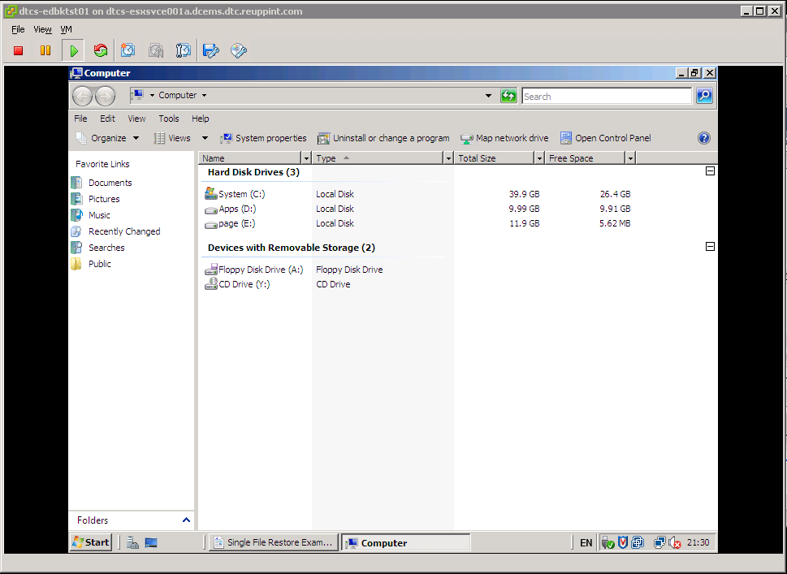
Figure 22 - Confirmation that the disk is removed from the VM

  - Now remove the FlexCloned datastore from the ESX server (This process is important, if the FlexClone is not removed it will eventually cause snap shots to fill up and fail) and follow the process in section 7 remove the FlexClone.

Manual Process for Netapp FlexClone Removal

  - Unexport the filesystem you previously exported.

vfiler run <vfiler_name> exportfs -z /vol/<volume_name>_clone/qtree_name

  - Remove the volume from the vfiler

vfiler remove <vfiler_name> /vol/<volume_name>_clone

  - Destroy the clone

vol offline /vol/<volume_name>_clone

  - Wait at least 48 hours (in case of mistake)

vol destroy /vol/<volume_name>_clone

